HOW TO INSTALL PYTHON 3

1. **Open** the following link ( [https://www.python.org](https://www.python.org/) )
2. Select the **Downloads**.

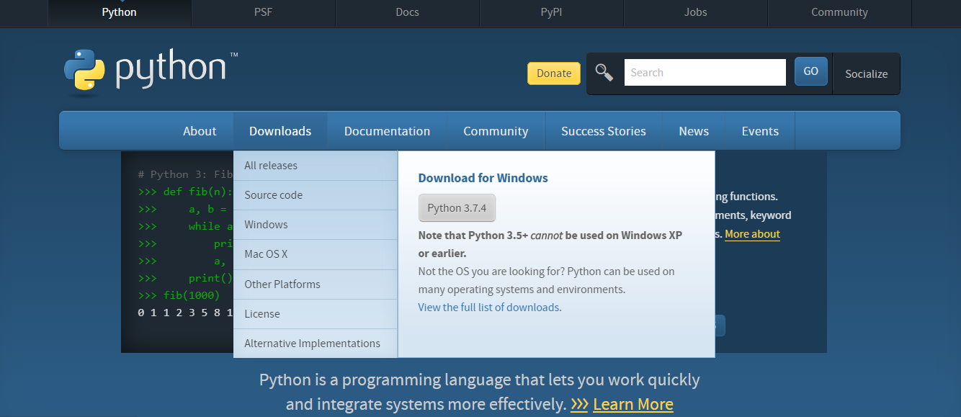

1. Download the **latest version** of python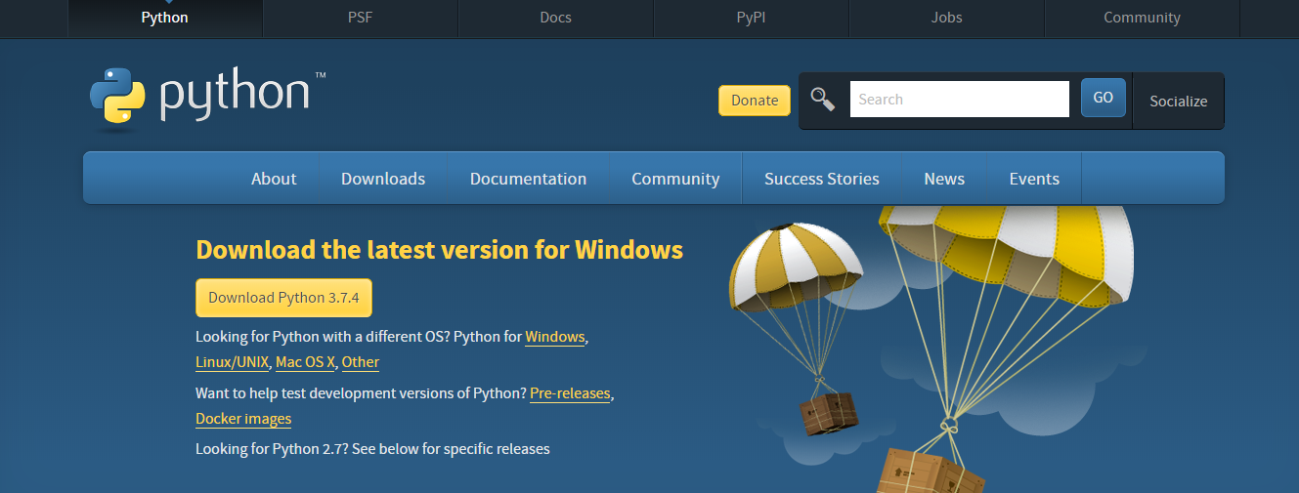
2. Install the downloaded **.exe** file. *NOTE 🡪 **DON’T forget to click add to PATH OPTION** WHILE INSTALLING.
3. After Installation open ***cmd*** .
4. Type **pip –version 🡪** It will show the current version of pip and python that is installed in your system.

**HOW TO INSTALL KIVY IN YOUR WINDOWS MATCHINE**

1. Open the following link [(<https://kivy.org/#download>)](https://kivy.org/#home) and select your machine. For windows click in the **INSTALLATION ON WINDOWS. OR ELSE YOU CAN FOLLOW THE FOLLWING STEPS TO INSTALL KIVY IN YOUR MATCHINE.**
2. **OPEN CMD.**
3. Copy and paste the following command to Ensure you have the latest pip, wheel, and virtualenv .If not there it will install the latest version.  
     
   🡪 **python -m pip install --upgrade pip wheel setuptools virtualenvpython**

OPTIONAL STEPS🡪 4 & 5

1. First create the environment named kivy_venv in your current directory:  
     
   🡪 **python -m virtualenv kivy_venv**
2. Activate the virtual environment. You’ll have to do this step from the current directory **every time** you start a new terminal. On windows CMD do:  
     
   🡪 **kivy_venv\Scripts\activate**

MENDITORY STEPS 🡪

1. Install the dependencies (skip gstreamer (~120MB) if not needed, see [Kivy’s dependencies](https://kivy.org/doc/stable/installation/installation-windows.html#kivy-dependencies)). If you are upgrading Kivy, see Updating Kivy from a previous release:  
     
   🡪 python -m pip install docutils pygments pypiwin32 kivy_deps.sdl2==0.1.22 kivy_deps.glew==0.1.12  
     
   🡪 python -m pip install kivy_deps.gstreamer==0.1.17
2. Note

If you encounter a *MemoryError* while installing, add after *pip install* the *–no-cache-dir* option.

For Python 3.5+, you can also use the angle backend instead of glew. This can be installed with:

* python -m pip install kivy_deps.angle==0.1.9

1. Install KIVY :   
     
   🡪 python -m pip install kivy==1.11.1
2. There are 3 Kivy Dependencies :  
   9.1) getstreamer for audio and video.  
   9.2) glew   
   9.3) sdl2 for control and OpenGL.
3. Both the python and the Python\Scripts directories **must** be on the path. They must be on the path every time you recompile kivy.
4. Ensure you have the latest pip and wheel with :  
     
   🡪 python -m pip install --upgrade pip wheel setuptools
5. Set the environment variables. On windows do:  
     
   🡪 set USE_SDL2=1  
   🡪 set USE_GSTREAMER=1
6. Install the other dependencies as well as their dev versions (you can skip gstreamer and gstreamer_dev if you aren’t going to use video/audio). we don’t pin the versions of the dependencies like for the stable kivy because we want the latest:  
     
   🡪 *python -m pip install Cython==0.29.10 docutils pygments pypiwin32 kivy_deps.sdl2 kivy_deps.glew kivy_deps.gstreamer kivy_deps.glew_dev kivy_deps.sdl2_dev kivy_deps.gstreamer_dev*
7. Start installation of Kivy cloned or downloaded and extracted from GitHub. You should be in the root directory where kivy is extracted containing the setup.py file:  
     
   *🡪 python -m pip install*
8. For Any Quarry, refer 🡪 <https://kivy.org/doc/stable/installation/installation-windows.html>
9. Python Documentation Link 🡪 <https://docs.python.org/3/tutorial/index.html>
10. Kivy PYPI Link 🡪 <https://pypi.org/project/Kivy/>